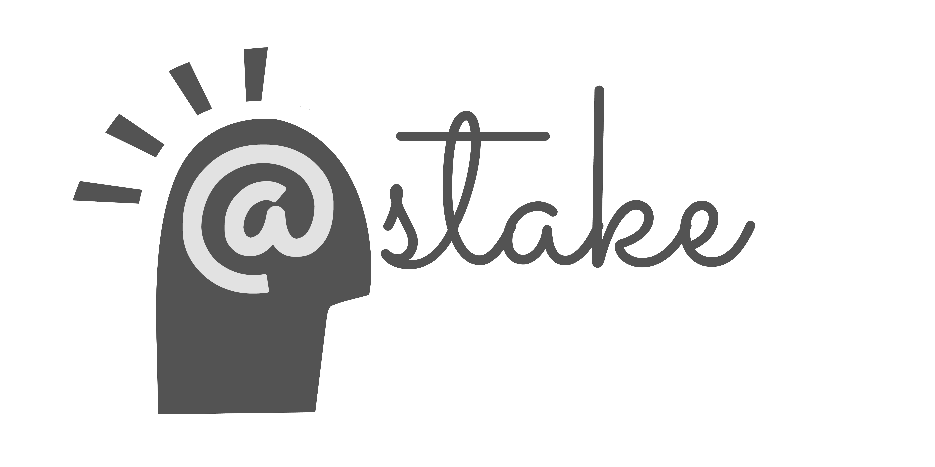
@Stake Gameplay and Participatory Budgeting: Implementation Reflections

Introduction
The @Stake game was piloted in three Participatory Budgeting meetings in New York City in Fall 2014 to foster engagement in the process, strengthen participants’ social ties with each other, and increase familiarity with deliberation. @Stake is designed to facilitate role-play as a means of introducing new perspectives to PB participants, as well as creating a safe space for idea generation and deliberation.. An impact evaluation was conducted by the Engagement Lab to investigate learning and civic outcomes that emerged from gameplay.

The @Stake Game
@Stake is a role playing card game designed by the Engagement Lab at Emerson College to foster empathy and collaboration among stakeholders, while brainstorming solutions to real world problems. @Stake was designed to enhance civic-oriented processes like community and government meetings. During the course of three rounds players brainstorm, pitch, and debate issues specific to their community. Examples of issues are: improving literacy, neighborhood participation, access to healthy food, etc. In @Stake, players act out a variety of roles and pitch ideas under timed pressure, competing to produce the best idea in the eyes of the table’s “Decider”. The roles represent diverse stakeholders in the affected community such as single parents, elected officials, activists, artists, data specialists, veterans, etc. Players practice a wide range of skills including improvisation and deliberation throughout the game. In debate, players balance personal agenda items on their role cards with those of the collective good, while considering opinions that differ from their own. The winner (the player with the most points after three rounds) wins a prize such as a candy bar. Additionally, the game is followed by a debrief where players are guided through a reflection on their game experience, and how it connects to larger community issues. @Stake has been adapted for contexts such as conferences, UN policy meetings on youth unemployment in Moldova, Egypt and Bhutan, educators’ curriculum design workshops, organizational planning, etc.,. The Engagement Lab is currently working on a mobile version of @Stake with the hopes of increasing accessibility and scalability while decreasing production costs.

Study Design
This study utilizes a mixed-methods approach through participant observation, survey data collection, and follow-up interviews for the November 2014-March 2015 PB process. @Stake was played during three budget delegate meetings in New York City in different districts that were selected for diversity within socio-demographic backgrounds. For the majority of participants, this was their first time engaging with the participatory budgeting process. Three districts were surveyed as the control groups, which did not play @Stake during their meetings. Participants were surveyed afterwards and offered an optional opportunity for semi-structured follow-up interviews. The survey questions focus on attitudes towards fellow meeting participants as well as civic engagement and assess whether gameplay increased empathy. To measure efficacy, we asked participants to rank perceptions of the participatory budgeting process, assess their satisfaction, and whether the workshop has impacted their decision-making. Observation of gameplay was planned to take note of players’ affinity toward civic engagement, player behavior, game strategy, and partnership and trust building between teams of players.

Short-term Objectives | Mid-term Objectives | Long-term Objectives
Social awareness | Deeper commitment to process | Open to more process
Greater willingness to listen | Increased empathy | Advocacy beyond self interest
Novel ideation | Increased creative ideas in PB | Increased creative ideas beyond PB
Enhanced systems-thinking issues in the game | Enhanced systems thinking about budget | Enhanced systems thinking about gov’t
Comfort w/ deliberation | Greater participation in PB | Continued involvement in community process
Attend to issues of procedural fairness | Greater ability to evaluate fairness in PB | Increased commitment to social justice
Table 1: Learning and Engagement Theory of Change for @Stake Gameplay with the Participatory Budgeting Project

Iterations and Adjustments
Approximately 45 people attended the first budget delegate orientation meeting where @Stake was played. Most of the attendees completed the survey after game play. One participant expressed dissatisfaction with being required to play and left the meeting, while another participant was vocal with her dissatisfaction but stayed until the end of the meeting. The gameplay was envisioned to substitute for the icebreaker portion of the meetings, which usually features a trivia activity. @Stake was played following a 20-minute introductory presentation. Before gameplay begun, the facilitators played an instructional demo round, since the video tutorial was still in production.
For the second budget delegate meeting, the game was played after budget delegates broke up unto their respective committees. The rationale was for less shuffling among the participants and made sense in the context of the game functioning as an icebreaker for the committees. In the second meeting, Josh Lerner the Executive Director of the Participatory Budgeting Project was present and provided further context for the use of @Stake by explaining that participants in previous years asked for activities that would enable group cohesion and increased learning about the process. While the first budget delegate meeting was in a large hall, the second meeting was in a more intimate room, which helped for clarity and ease. The second meeting also had a thorough debrief while the first meeting’s debrief was somewhat rushed due to time constraints. In the first meeting, several Participatory Budgeting volunteers filled out game observation forms while in the second meeting researchers decided that the interpretations of gameplay observations were not standardized enough to continue with and would require longer training.
The third game play was in a crowded room and had several logistical complications when the meeting started significantly later than planned and the projector did not work to display the video tutorial. Timing constraints led to only two rounds of @Stake played, instead of the typical three rounds, and the debrief was shortened. Despite the abbreviated version of this experience, researchers were able to collect completed surveys from over half of the participants and 19 of them expressed an interest in a follow-up interview.

Process Reflections
Since games are a fairly novel medium, they are often contextualized as an experiment. Due to this frame, gameplay in civic contexts often experience a challenge of legitimacy as players confront a tension between seriousness and play. The conditions for this tension can be especially present in community meetings where some participants have arranged for childcare and negotiated other obligations and could have stronger senses of urgency that they are spending their time well. In this study, it was helpful to emphasize that the game was chosen based on requests from past delegates that asked for more ways to learn about different perspectives in the community and to get to know each other. Several measures to confront this natural resistance to gameplay can include a thoughtful introduction to the game that addresses its relevance and a commitment to a thorough debrief that allows players to share their insights. The research team also found it important to stress how games could require some adjustment, where at first instructions may appear overwhelming but the experience of playing often allows for understanding to unfold over time. From the three experiences of gameplay at participatory budgeting meetings, some of the internal and external factors that influence how seriously a game is perceived are mentioned below.
This pilot study is unfunded so there are limitations with staff resources to train facilitators and collect data from game observations, surveys, and interviews. With more resources slated for this project, many of the recommendations below could be more feasible. The process reflections fall into categories of staff capacity, increased procedural awareness, and game revision.

1. Staff Capacity and Facilitation
The process for planning to play @Stake in the participatory budgeting meetings involved administrative coordination between Project Managers at the Participatory Budgeting Project and the Engagement Lab at Emerson College. Before each game implementation, researchers were virtually introduced to district council members that lead the meetings and volunteers from the PB project. On-site, meeting facilitators, volunteers, and researchers set up the game materials and surveys at each table and were briefed on the game rules prior to the meeting. In the first meeting, several volunteers filed out game observation forms. In all the meetings, volunteers played @Stake with participants and were a helpful resource due to their increased familiarity with the game.
Meeting facilitators should be trained more thoroughly in game facilitation, which would increase efficiency and ease. For instance, trained facilitators could more readily acclimate participants to the game materials as they enter the room, clarify questions about the game, and encourage meaningful reflection and follow-up after the game. Increased opportunities for game facilitation training could also foster more staff buy-in, since many facilitators are exposed to games in a civic context for the first time on the day of the meeting. We found that some of the enthusiasm of facilitators was influenced by logistical constraints. For example, one meeting that started late resulted in a shortened game and debrief so that the facilitators had enough time to convey important participatory budgeting information. Increased opportunities for facilitator training could allow for greater clarity on the relevance and potential benefits of gameplay with more comfort of how to adapt to time constraints, should they arise.
There is potential for game facilitator trainings to also enhance deliberation and research skills as well as public speaking confidence of Participatory Budgeting interns and meeting facilitators. There is room for additional role development for internal staff, as timekeepers and rule-observers to help during the initial start of the game. More training would also allow for scalability of the game and increased opportunities for research through game observation and survey data collection.

2. Procedural Observations
The timing of the game can make a significant difference with the flow of the meeting, including enthusiasm and social cohesion of players. Gameplay occurring after the introduction but before the delegate committee discussions allows for experiential learning opportunities that are not merely didactic or discussion-based. However the introduction to the game and debriefing are important moments of transition to ensure the relevance of the game. The biggest obstacle to the smooth transition is often timing since there is a lot of information that needs to be addressed in the orientation meetings. There are possibilities for the schedule of the meetings to be adjusted accordingly as well as for the game to be shortened to allow for richer introductions and reflections.

3. @Stake Game Revisions
Because of time constraints observed in meetings and after receiving feedback from meeting facilitators, the research team is simplifying the game mechanics to improve clarity in addition to creating a mobile version of the game. Some examples of specific points of feedback include: printing larger instruction sheets for players with limited vision, renaming the first step from “brainstorm” to “think up ideas" or "develop a pitch" to better mirror the PB process, randomly appoint deciders to start the game faster instead of having them decide for themselves, revise role cards to include more marginalized community members as well as governmental gate keepers, etc.
The mobile version addresses many of these concerns by explaining instructions in a large font step-by-step during each phase of the game, automatically assigning roles, randomizing the order of people presenting their ideas, and allowing for deck customization where meeting facilitators can adapt existing roles to better reflect their community stakeholders. The mobile version is slated for an initial beta test with the youth-led participatory budgeting process in February 2015 in Boston. Increased funding would allow for further testing, proliferation, and revisions.

Future Iterations and Growth
Beyond creating a mobile version of the game, learning opportunities exist in
tracking ideas that are generated during the game, researching how the game impacts retention in the PB process, and improving the process for multimodal learning. For instance, it would be useful to take notes on a flipchart during debriefing so that visual learners may better track the discussion. Another unexplored topic during debriefing includes how the different groups of players managed deliberation. Some players felt less comfortable talking than others. It is important to explore this in more detail to understand precisely how the game impacts traditional power dynamics during group conversation.
Lastly, increased staff capacity could allow for an interactive design process where the Engagement Lab can playtest more versions of @Stake and incorporate the feedback of Participatory Budgeting staff and stakeholders. This type of design process could increase buy-in for utilizing the game and allow for greater integration into the participatory budgeting process.

