Memorandum of Understanding for Mutually Beneficial Research

Table of Contents
Introduction
What’s an MOU? 2
Why is an MOU Important? 2
How to Use the Template 2
Discussion Questions 3
Statement of Purpose 4
Mutual Interests 5-6
Shared Decision-Making 7-8
Data Ownership 9
Data Collection 10
Data Storage 10
Data Maintenance 11
Data Sharing 12
Agreement 13
Glossary 14
About CARP (Community-Academic Research Partnerships) 15

Introduction
What’s an MOU?
A Memorandum of Understanding for Mutually Beneficial Research (MOU) sets the ground rules, and defines the purpose and structure of a research partnerships that benefits both the researcher and the researched. It is a not a contract, but rather an articulation of terms. It is not legally binding, but it should serve as the foundation for research relationships based on trust and reciprocity, and a commitment to mutual benefit.

The Template
This document is divided into three sections: mutual interests, shared decision-making, and data ownership along with italicized examples. It is meant to be filled out in conversation. Collaborators should sit together and discuss the answers to each question, allowing approximately 60 minutes to get through the document. However, prior to doing this, it is recommended that the lead partner revise or remove statements that are not appropriate to the specific project. This template is meant only as a starting place and Community Partner Organizations (CPOs) and researchers are encouraged to use, change, and add information to this MOU template.

How to use the Template
Step 1: Complete a Preliminary Assessment
Use the discussion questions below to assess what elements of the research relationship need the most attention.
Step 2: Modify the MOU Template
Based on conversations with partner(s), revise the MOU Template to appropriately reflect your project. You may create new categories if needed.
Step 3: Complete the Template
Sit together (if possible) and fill in the blanks. Some of the more descriptive blanks can be pre-populated, but most should be filled out together to reflect your shared objectives.
Step 4: Revisit and Evaluate
Your text is a living document. You may find it necessary to review and make changes to the MOU as your project evolves.

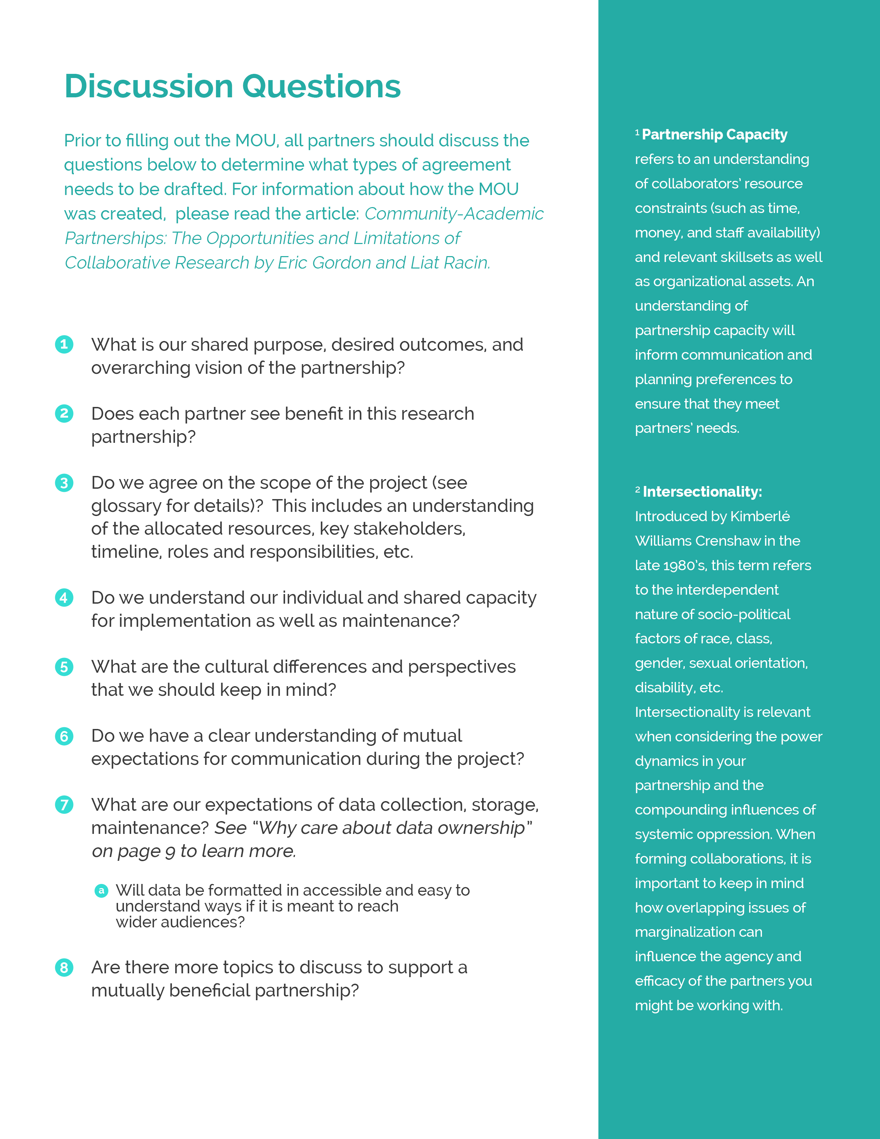

Statement of Purpose
All partners should be clear about the purpose of the research, and have a clear understanding of the terms of the collaboration.

This MOU is a voluntary agreement between the community partner organization (CPO) ____________________________, and the academic partner____________________________ as a part of their involvement in ___________________________________________________ (name of research project/program), funded by (if applicable) _____________________. The purpose of this research partnership is to ____________________________________________________________________________
(i.e. examine an issue/prototype and design digital tools).

The academic partner wishes to enhance its ____________________________________________
(i.e. course offerings, publications), in order to achieve _____________________________________ (goal) through this partnership.

The CPO wishes to enhance its _______________ (i.e. Engagement of youth), in order to achieve _______________________(goal) through this partnership.

The outcome of the research will be to ______________________ (i.e. inform policy/evaluate a plan of action etc.), which addresses the above issue within the community.

The community is understood here as __________________ (identify how community is defined).

Optional Section
Other explicit purposes for partnership not captured above include:________________________ (to foster a long-term working relationship between the partner and academic institution)

Mutual Interests
To ensure a level playing field, project planning, research and design processes should be relevant to the community served. The focus of the project should meet the needs and interests of the CPO, and the goals and outcomes of the partnership should do the same.

We share a common interest in addressing the high priority issue(s) of _____________________ (poverty, health education, youth homelessness, etc.) in the community. The project is trying to accomplish ________________________ (increased service learning opportunities, improved volunteer retention, more intergenerational learning opportunities).

Describe the benefits of the partnership for the academic partner. (i.e. learn about community needs and the implications of public policy)

The collaboration is not in conflict with the CPO’s initiatives and priorities, and it is beneficial and relevant to the work of the CPO. Describe how the partnership will address the CPO’s immediate needs and interests. (i.e. the CPO has a need to revise their database and the academic partner is able to assist in doing so while collecting research data)

The timeline of the project is in line with the CPO’s timeline. Describe the process for ensuring that expectations for fulfilling obligations are met: (i.e. report deadlines, using a project management system, reviewing the timeline at weekly meetings)

The project should not interfere with the CPO’s ability to carry out its day-to-day work. Explain how the aims and objectives of the project are realistic and achievable for the CPO. (i.e. reasonable use of staff time/administrative resources, sensitivity to meeting CPO’s during their work hours).

Identify the perceived risks of project participation for the CPO and/or third party stakeholders, and describe how risks will be addressed, minimized and/or eliminated (i.e. work with youth will involve filling out consent forms ahead of time).

Describe the long-term benefits of participation for the CPO: (i.e: this research project will improve the CPO’s portfolio for applying to more grants in the future)

Describe how the project will function to enhance the capacity of the community: (i.e. it will offer technical trainings, jobs, opportunities to sustain projects long-term)

How will the project’s beneficial outcomes for the community be sustained and developed after the duration of the partnership? (i.e. a student intern program will be created)

List any other mutual shared interests not expressed above:

Shared Decision Making
Decision-making affecting the dynamics of the partnership and project must be mutually agreed upon. Information-sharing at all levels should be a constant undertaking, and partners need to recognize each other’s expertise and skills - or means to build and access them - in order to collaboratively work toward achieving project goals in ways that leave the community better off after the project.

List all stages of the research  (i.e. identifying/defining the problem; creating a data collection plan; data collection; interpreting data; evaluating plans of action; designing digital instruments etc.) | CPO (Community Partner Organization) Involvement with Each Stage  Describe what plans and strategies will be used to ensure CPO participation in these stages, as appropriate.

The resources and expertise necessary for this project are _______________________________. The available funding is_____________________________________________________________________.

Identify the relevant strengths, sets of skills and resources that CPOs possess. (i.e. the CPO is a leading subject expert or has years of trust built from neighborhood partners)

Describe how different resources and expertise will be shared to influence and achieve the goals of the collaboration. (i.e. all of the working documents will be available in a shared, document)

Information and discussion points are out on the table. Identify and describe the channels of clear and open communication between partners that enable a regular exchange of information (i.e. face-to-face meetings; email or phone calls; community mailings; social media etc.)

Differences in culture, perspectives, and language may affect approaches to communicating, sharing information and making decisions. Academic partners will be made aware of and respect culturally sensitive issues and the rights of the community under investigation. What steps are in place to ensure that conflicts of interest are addressed and resolved in the future? (i.e. partners may request to hold a meeting at any point to discuss concerns and state their position; meetings are well-documented; recommendations for resolutions are consistent with the terms outlined in this MOU etc.)

List the appropriate contacts for specific matters related to this project and their contact information. Contact details will be kept up-to-date. (i.e. who is the point person for external communications about the project? For partnership-communications?)

How will the relationship between the CPO and the academic partner be maintained after the life of the project? (i.e. shared presentations about the work, informal gatherings, referrals to one another)

The partnership will last approximately _________ months and require about ____________ hours per week from the community and ___________ hours per week from the academic partner.

Data Ownership
There is a shared ownership of data in both digital and analog forms. The CPO can easily understand and access project-related data at any point during the partnership, and there is a plan for using it at the end of the collaboration.

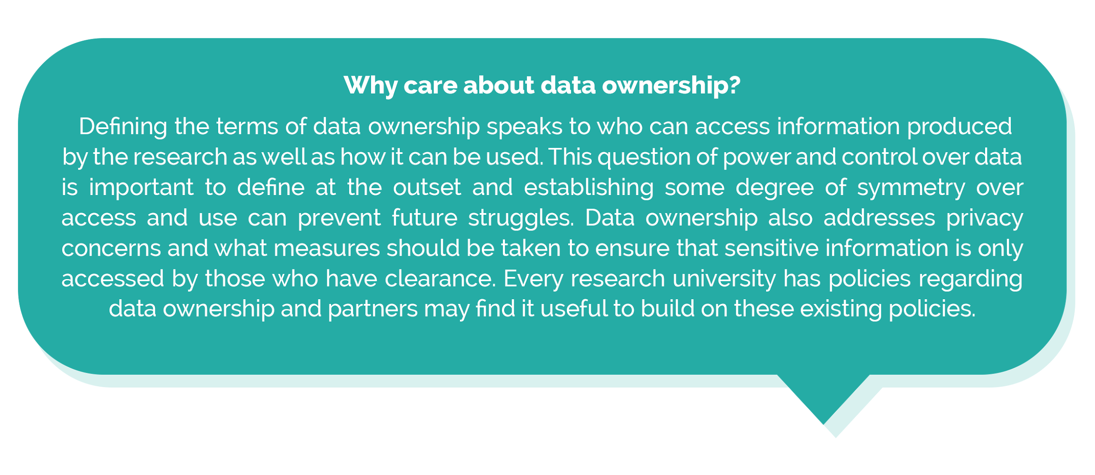
Data Collection
Describe what new data will be generated and/or collected from the partnership, and what existing data will be shared and reused?

CPOs may require technical and/or financial support to participate more fully in data collection, generation and analysis. Identify and describe how gaps will be filled to suit their needs, interests and ability to equally participate?

Who will analyze, review and interpret data used for the project?

The term, metadata, describes information that is based on data collected from the research (data that describes the data). Describe what metadata will be generated from the collaboration.

Data Storage
Data will be physically located ___________________________.
Data will be stored for _________ time.
How will data be securely stored, archived, and/or disposed in the long-term?

Data Maintenance
What are associated data maintenance costs?

The CPO may request data at any time. How are access requests handled?

Methods of managing and protecting data during the course of the project include:

List the technical and procedural methods for protecting confidential information:

CPOs may need the technical infrastructure or tools to ensure long-term usability of digital files and materials. Describe how digital data can be transitioned over to CPOs in a useable and appropriate manner at the end of the partnership.

Who has access to and the rights to use digital products after the termination of the partnership?

Data Sharing
Describe how born-digital (materials that originate in a digital form) as well as digitized materials are appropriate for CPOs in terms of their accessibility and usability.

Participants will agree on who has access to project-related data and under what conditions. List the current stakeholders and owners of the data as well as potential stakeholders in the future:

Academic partners will produce, interpret and share findings with CPOs in an accessible and practical way. Identify the format of information sharing that ensures equal access and takes into account linguistic, cultural, and technological preferences for communication.

Besides the involved CPO, identify who will receive project-related data and through what means. (i.e. community members, partner organizations, funders etc.)

The findings and outcomes of the partnership will be shared with the community in ways that are geared toward education, advocacy, and social change. Describe what data will be shared, how it will be shared, and a timeframe for data sharing.

What types of current and future uses of the data are permissible?

CPOs may use the collected data and new knowledge discovered through this partnership ___________(with/without) mutual consent.

Consent _____________________(must/may not) be obtained from partners before using data in any purpose other than the purpose of this project.

Digital and analogue products resulting from the project will acknowledge the contribution and knowledge of CPOs. Describe how CPOs will be consulted prior to the submission of materials for publication and be invited to collaborate in project-related design, material and production processes.

Do CPOs wish to publically share all data generated and/or collected during the partnership? Y/N?

What are the risks of using and sharing the data? How will these risks be addressed and minimized?

Agreement
If partnerships are no longer mutually beneficial, and changes that impact community participation occur, either party may end the collaboration.

Signatures:

This Memorandum of Understanding is entered into on _______________________(date)

Academic Partner(s)

____________________________________ (print name)

____________________________________ (signature)

Community Partner Organization(s)

____________________________________ (print name)

____________________________________ (signature)

Glossary
CPO: Community Partner Organizations can include NGO’s, non-profits, or informal community-based groups.

Data: Data is the Latin term for “given”. Data are observations about the world that are collected and organized in a systematic way. Data can be qualitative (such as stories or artworks) or quantitative (such as spreadsheets and maps).

Big Data: On a most basic level, big data refers to large-scale datasets such as the census and social media feeds. Big data exists as social and technical phenomena, therefore describing big data also includes describing the social contexts and computational literacies that surround it. As Danah Boyd and Kate Crawford write in a 2012 article: “Big Data is less about data that is big than it is about a capacity to search, aggregate, and cross-reference large data sets.”

IRB: An Institutional Review Board exists to ensure ethical compliance and protection of human rights for research projects in the United States. The IRB model has existed since the mid 1970’s and has largely been used in the context of biomedical research studies. This MOU template was created from noticing gaps in ensuring mutually beneficial research partnerships in the IRB process for social sciences research.

Project Scoping: The process for defining project parameters, including: project needs (such as supplies and budgets), timelines (such as for launches, partnerships, etc.), and roles as well as responsibilities of team members. A proper project scope clearly outlines the necessary elements for a project to be successfully completed given the constraints of the environment and takes into account stakeholder input and needs.

About this Memorandum of Understanding

This MOU template was developed in response to an identified need to balance the power in research collaborations between community partner organizations (CPOs) and academic institutions working in the Social Sciences. The template can guide CPOs when entering into partnerships that build community capacity as it highlights key issues to consider for making research processes clear and mutually beneficial.

The content and basic terms used in this template are based on major themes from a study, entitled A Community Approach to Research Partnerships (CARP), which was conducted in 2015-2016 by Eric Gordon and Liat Racin at the Engagement Lab at Emerson College, in collaboration with Boston Civic Media. CARP examined and synthesized some of the prevalent trends, issues, and concerns of community-academic partnerships from the experiences of CPOs in Boston. The goal of the study was to examine the major challenges and aspirations for community partners in research relationships.

It is important to underline here that drafting MOUs can provide useful opportunities to discuss and negotiate the expectations of each partner and broker competing agendas. It may not always be an easy and straightforward process, but preparing and agreeing to a MOU can help pave the way to mutually beneficial research.

